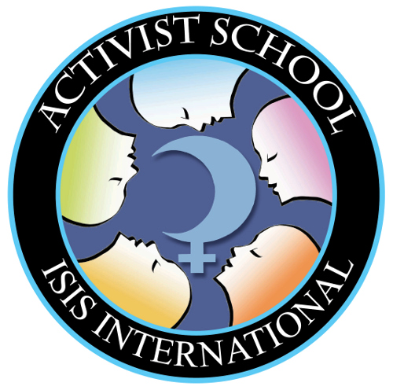
Isis International Activist School for

Women Human Rights Defenders
Submit your completed application form to nicole@isismanila.org by 31 January 2014

Personal Information
Title | Dr | Mr | Mrs |  | Ms |  | Other:
First Name
Last Name
Preferred Name
Organization
Position
Date of Birth (MM/DD/YYYY)
Gender
E-mail
Skype Name
Phone/Mobile phone | Country Code (+ )
Address
Country where you currently reside
Languages/Dialects Spoken and Proficiency
* The training workshop will primarily be conducted in English, thus proficiency in English is a requirement. | Language |  |  | Beginner |  | Intermediate |  | Advanced
 | English*

Travel Information
Nationality
Country where your passport was issued
Name in Passport
Passport Number
Issue Date (MM/DD/YYYY)
Expiry Date (MM/DD/YYYY)
* Please ensure your passport is valid for a period of at least six (6) months after you are due to leave the Philippines.
I have scanned and attached a copy of the front page of my passport.

I have confirmed the conditions for travel to the Philippines, and if necessary am capable of fulfilling the visa requirements.

* For further information visit the Philippine Department of Foreign Affairs website: (https://www.dfa.gov.ph/index.php/site-administrator/visa-information)
Which city will you be departing from?
Which city will you be returning to?

Dietary and Other Needs
None | No pork | No meat | No meat and no fish |  | No animal products (vegan) |  | Other dietary requirements:
Do you have any health issues or travel needs that we as organizers need to be informed of? Please list any ailments that you are currently being treated for, or taking medication for.

Emergency Contact
Full Name
Phone/Mobile Number |  |  |  | Country Code (+ )
Email

Needs Assessment

Why do you want to take part in the Activist School for Women Human Rights Defenders?

Are there any specific knowledge or skills you expect to gain from this training workshop?
- Please describe the work you do in your organization and/or in your community. Why have you chosen to work in this area, and what do you hope to achieve?
- Would you define the work that you do as defending women’s human rights? Why? Why not?
- Please describe 3-5 challenges that you face as a women human rights defender.
- What strategies have you employed to address each of these challenges?
- What skills and experiences do you have to offer others at the Activist School for Women Human Rights Defenders?
- How many capacity building workshops have you attended in the last three years? If possible, name the issues/skills that were covered.
- Any other comments/suggestions?

References (People who know you well as an activist)
 |  | Reference 1 |  |  |  | Reference 2
Full name
Organization
Position
Email
Phone/Skype |  | Country Code (+ ) |  |  |  | Country Code (+ )

Further Information
How did you find out about the Isis International Activist School for Women Human Rights Defenders?
Friend | Colleague |  | Your Organisation | Isis Facebook | Isis Website |  | Isis Newsletter | Other (please specify):
Isis International produces ‘we!’ an e-newsletter that provides the latest information on the issues, campaigns, conferences, training opportunities, funding possibilities and other goings-on in the women's movement. It also provides updates on national, regional and international events organised by NGOs, government bodies and multilateral agencies that impact women.
I do not want to receive ‘we!’

Declaration by the applicant

If selected for the Isis International Activist School for Women Human Rights Defenders, I understand that:
- I will be in attendance for the entire duration of the training and take responsibility for my own learning experience. I must notify Isis International at the earliest possible opportunity of factors that may prevent my participation.
- I am responsible for obtaining a visa to travel to the Philippines. If I am not able to obtain a visa, for any reason, then I will not be able to attend the Isis International Activist School.
- I agree that personal information provided by me in relation to the Isis International Activist School may be used for the purposes of administering and evaluating the program.
- I will take part in the post Isis International Activist School tracer study which takes place 4-6 months after the training.

Signature: _______________________________

Print Name: _______________________________

Date: _______________________________

Please send your application to Nicole Hutchison (nicole@isiswomen.org) on or before 31 January 2014. Successful applicants will be notified via email by 14 February 2014.

